**AEARU Winter Abroad Program 2024-2025**

**at Yonsei University**

**Program Summary**

**◈ Title:** Winter Abroad at Yonsei (WAY)

**◈ Date:** Dec. 27, 2024 ~ Jan. 17, 2025

**◈ Location:** Yonsei University, Main Sinchon Campus

**◈ Organized by:** Yonsei University Office of International Affairs

**◈ Size:** Approximately 900 student participants

**◈ Language:** English

**◈ Website:** <http://winter.yonsei.ac.kr>

**Introduction**

In the 2024-2025 Winter Abroad at Yonsei, Yonsei University offers a 3-week winter program at our Sinchon campus for international students who would like to enjoy the winter in Seoul. we focus on academic achievement with various course and provides opportunities to travel around Seoul and experience Korean culture. Such as the DMZ tour, SKI trip, and Korean cooking class.

We provide an excellent opportunity to enhance your scholarship, interact with eminent professors, and enjoy the companionship of participants from all over the world.

The oldest private university in Seoul, Korea, Yonsei University was first established in 1885 by Christian missionaries. Our mission is to educate leaders who will contribute to humanity in the spirit of “truth and freedom.” The 350,000 Yonsei alumni who take this calling to heart can be found manifesting this proud spirit from leadership positions around the world.

Yonsei’s main campus is ensconced in a spacious, picturesque, and natural setting located minutes away from the economic, political, and cultural centers of Seoul’s metropolitan downtown. Yonsei has more than 6,200 eminent faculty members who are conducting cutting-edge research across all academic disciplines. There are 20 graduate schools, 28 colleges, and 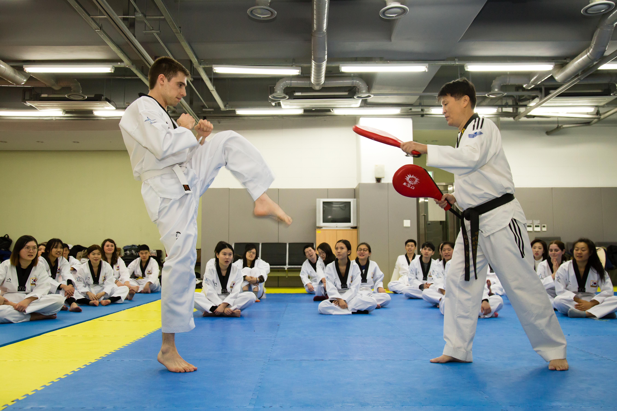166 research institutes that host an elite pool of students from around the world.

**Inviting AEARU Member Institutions**

Yonsei University is pleased to extend an invitation to participate in the 2024-2025 WAY program. We would like to offer each university the opportunity to nominate one student for this prestigious scholarship. If there are not enough nominated students, each university will have the opportunity to nominate more than one student on a first-come, first-served basis.

Please note that the scholarship will be awarded on **a first-come, first-served basis, up to a total fund amount of USD 10,000**. We encourage you to act promptly in order to secure this financial support for your nominated student.

**Fees**

|  |  |  |  |
| --- | --- | --- | --- |
| **Item** | **Amount (KRW)** | **Responsibility of** | **Remarks** |
| Application Fee* | 100,000 | Student |  |
| Tuition fee for regular period | 1,770,000  (1 course) | AEARU (50%) & Student (50%) | 50% support from AEARU Fund |
| 2,970,000  (2 courses) |
| 3,770,000  (3 courses) |

**\*Application fee is non-refundable**

**\*\*Early Bird Promotion and AEARU Associate University Scholarship (KRW 100,000) is not applicable for AEARU-Yonsei scholarship recipients.**

**Class Schedule**

|  |  |  |  |  |  |
| --- | --- | --- | --- | --- | --- |
| **Item** | **Mon** | **Tues** | **Wed** | **Thurs** | **Fri** |
| Morning Course (3 credits) | 09:30 – 12:00 | | | | |
| Afternoon Course (3 credits) | 13:30 – 16:00 | | | | |
| Video Lecture  [online only] | Students can take classes at convenience within each class deadline  (Video lectures, not real-time) | | | | |

| **Period** | **Course Title** | **Credit(s)** |
| --- | --- | --- |
| Morning Courses  (9:30 ~ 12:00) | MEDIA PSYCHOLOGY | 3 |
| Introduction To Data Science | 3 |
| PRINCIPLES OF MICROECONOMICS | 3 |
| KOREAN ECONOMY | 3 |
| KOREAN LANGUAGE 1(Morning) | 3 |
| KOREAN POPULAR CULTURE AND KOREAN WAVE | 3 |
| PRINCIPLES OF MARKETING | 3 |
| STRATEGIC MANAGEMENT | 3 |
| CONTEMPORARY KOREAN CINEMA AND SOCIETY | 3 |
| SOCIAL PSYCHOLOGY | 3 |
| SCIENCE MEDICINE AND SOCIETY | 3 |
| EASTERN CIVILIZATION | 3 |
| Afternoon Courses  (13:30 ~ 16:00) | PRINCIPLES OF MACROECONOMICS | 3 |
| ECONOMETRICS (1) | 3 |
| KOREAN LANGUAGE 1 | 3 |
| KOREAN LANGUAGE 2 | 3 |
| KOREAN LANGUAGE 3 | 3 |
| INTRODUCTORY PSYCHOLOGY | 3 |
| MODERN KOREAN HISTORY | 3 |
| STRATEGIC MANAGEMENT | 3 |
| FINANCIAL ACCOUNTING | 3 |
| UNDERSTANDING K-POP | 3 |
| INTRODUCTION TO BIG DATA ANALYSIS | 3 |
| KOREA AND THE WORLD | 3 |
| Introduction To Statistics | 3 |
| Introduction to Statistics | 3 |
| MODERN KOREAN LITERATURE | 3 |
| Video Lecture | GAME THEORY AND APPLICATIONS | 3 |
| LAW AND ECONOMICS | 3 |
| INTRODUCTION TO COMPUTER GRAPHICS | 3 |
| AI & DESIGN | 3 |

*Course lists as of 2023-2024 WAY program. Courses and information are subject to change so we recommend students to check the website for the most up to date information

**Important Dates**

1. Deadline for Nomination for AEARU Member Institutions: October 31, 2024

2. Online Application and application fee payment deadline for nominated student: November 14, 2024

3. Tuition fee payment deadline: November 28, 2024

4. Class Schedule: Dec. 27, 2024 ~ Jan. 17, 2025

**※Each student is responsible to check the deadline and follow the necessary procedures.**

**How to Apply**

1. Minimum GPA Requirement for Students: Above 2.0/4.0

2. Select and nominate one (1) student.

3. Submit completed registration form at the end of this page and an official transcript from home university to Yonsei via email [protocol@yonsei.ac.kr](mailto:protocol@yonsei.ac.kr) no later than October 31, 2024.

4. Yonsei will contact and inform the selected student of the admission and acceptance.

5. Procedure after nomination for Students

**Registration Form**

|  |  |  |  |
| --- | --- | --- | --- |
| **AEARU Winter Abroad Program 2024-2025 at Yonsei University**  **Registration Form (for AEARU Member Institutions)** | | | |
| Name in English | Family Name | First name | |
| Date of Birth(dd/mm/yy) |  | Department/Major |  |
| Home University |  | Email Address |  |
| GPA |  | Phone  (with country code) |  |
| *Please submit this registration form and official transcript  to [protocol@yonsei.ac.kr](mailto:protocol@yonsei.ac.kr), no later than October 31, 2024. | | | |

**Contact Point**

Office of International Affairs

Yonsei University

E. [protocol@yonsei.ac.kr](mailto:protocol@yonsei.ac.kr)

T. +82-2-2123-4436